**Experiment 1.2**

**Student Name:** TUSHAR GUPTA **UID:** 20BCS9268

**Branch:** BE-CSE **Section/Group:** 607/A

**Semester:** 6TH  **Date of Performance:**16/2/23

**Subject Name:** Mobile Application Development **Subject Code:**20CSP-356

1. **Aim:** To make text on android studio
2. **Objective:** Making first application, getting to know how to start UI editing and creation using Design and code in Android XML
3. **Code and output:**

* Open Android studio.
* Create project with name ‘My Application’
* Create an empty Activity

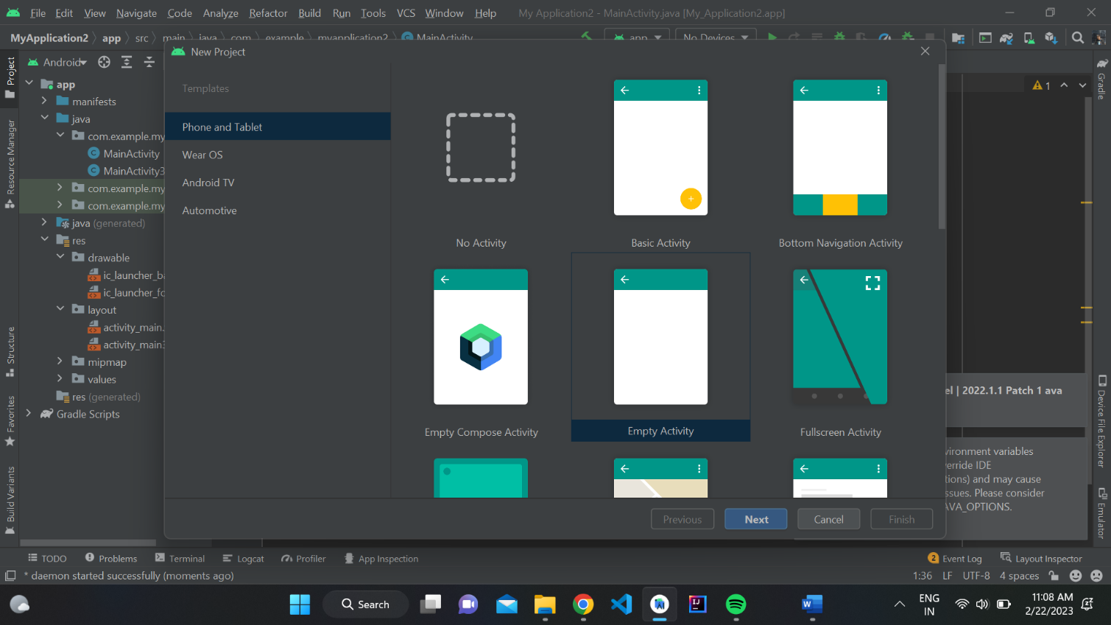

* Give names and other details.

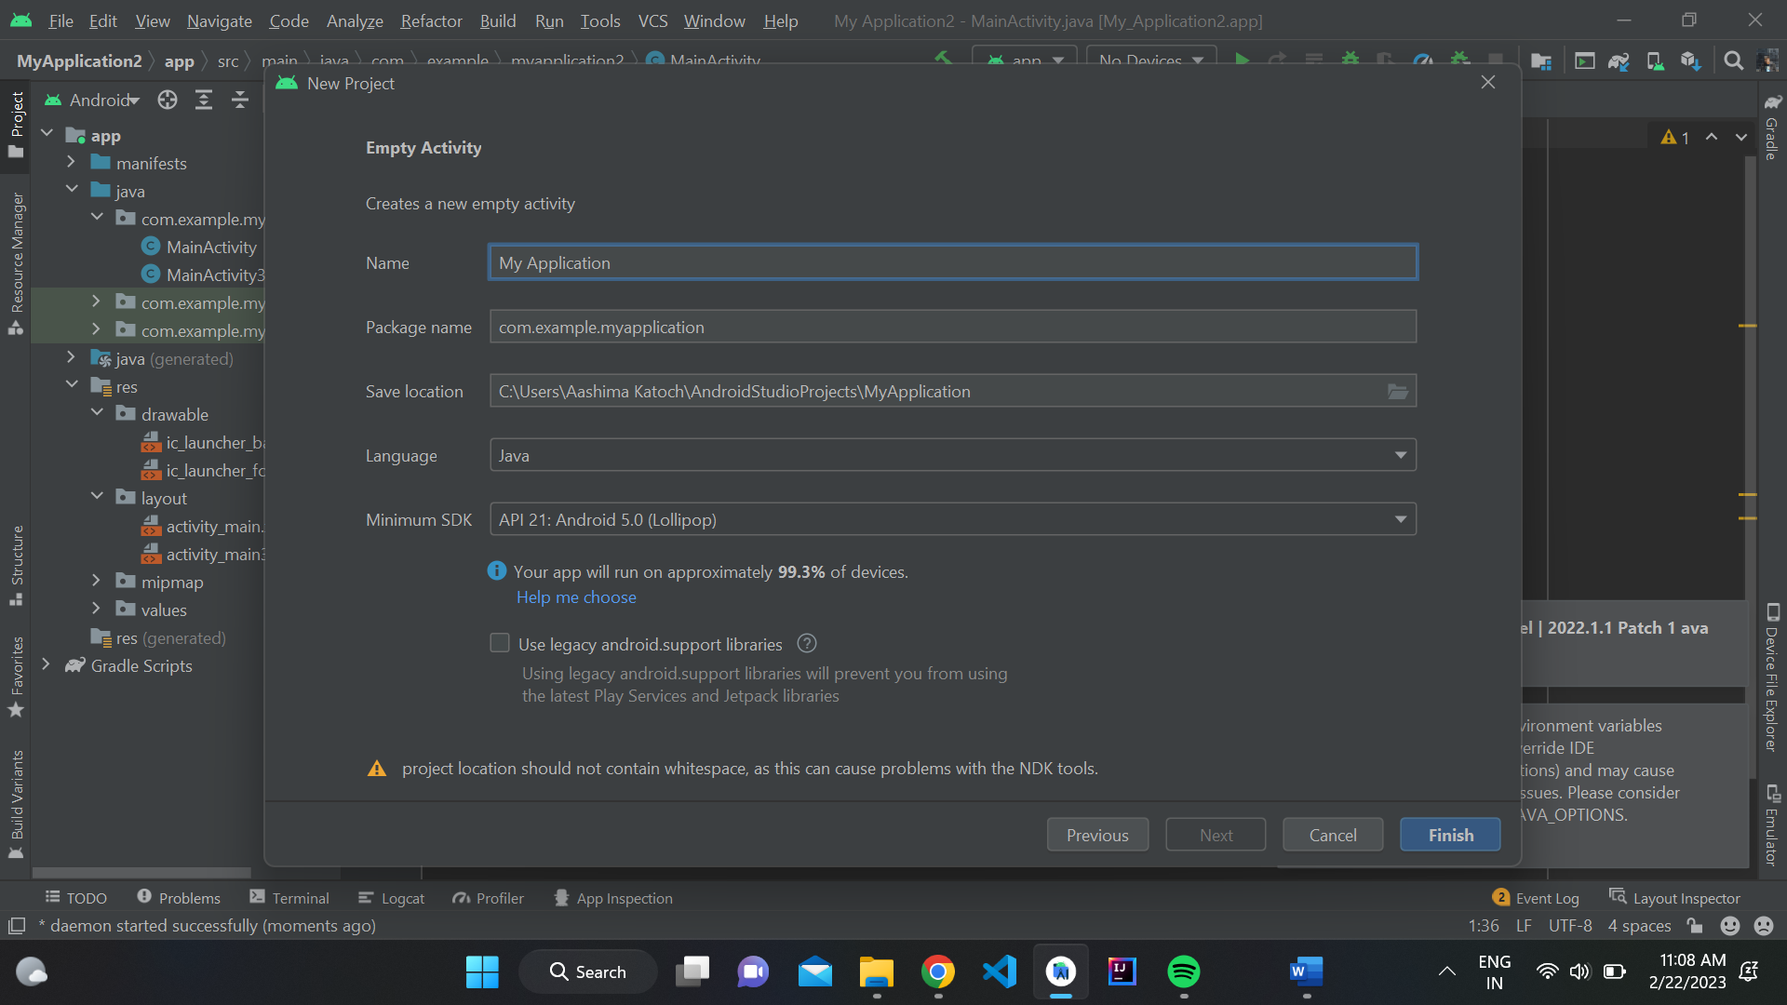

* The Main Activity is created, Open ‘activity_main.xml’ in ‘res/layout’ folder to start editing.
* Use Design view in Editor to drag and drop required views.
* Add a textview from the pallete to the screen
* Use Attributes tab to change shape ,size ,background , text and important details of the textview
* Position the view , edit and the write your own text

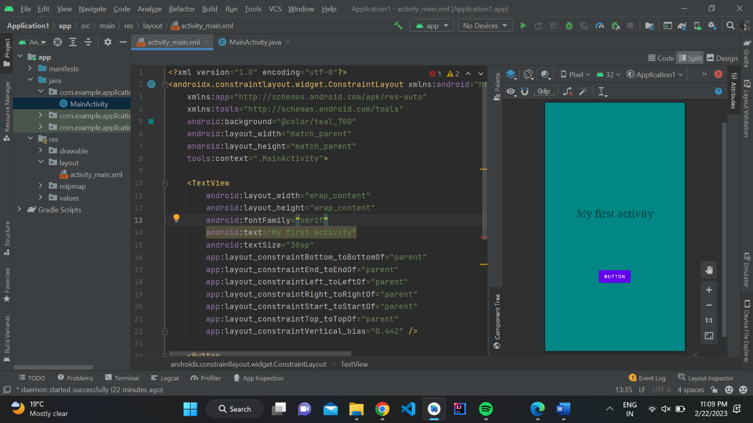

**Code:**

**MainActivity.java**

package com.example.helloworld;  
  
import androidx.appcompat.app.AppCompatActivity;  
  
import android.os.Bundle;  
  
public class MainActivity extends AppCompatActivity {  
  
 @Override  
 protected void onCreate(Bundle savedInstanceState) {  
 super.onCreate(savedInstanceState);  
 setContentView(R.layout.activity_main);  
 }  
}

**activity_main.xml**

<?xml version="1.0" encoding="utf-8"?>  
<androidx.constraintlayout.widget.ConstraintLayout xmlns:android="http://schemas.android.com/apk/res/android"  
 xmlns:app="http://schemas.android.com/apk/res-auto"  
 xmlns:tools="http://schemas.android.com/tools"  
 android:layout_width="match_parent"  
 android:layout_height="match_parent"  
 tools:context=".MainActivity">  
  
 <TextView  
 android:id="@+id/textView"  
 android:layout_width="wrap_content"  
 android:layout_height="wrap_content"  
 android:text="!!!Hello World !!!"  
 android:textSize="40sp"  
 android:textStyle="bold"  
 app:layout_constraintBottom_toBottomOf="parent"  
 app:layout_constraintEnd_toEndOf="parent"  
 app:layout_constraintHorizontal_bias="0.496"  
 app:layout_constraintStart_toStartOf="parent"  
 app:layout_constraintTop_toTopOf="parent" />  
</androidx.constraintlayout.widget.ConstraintLayout>

**OUTPUT:**

